Albert Wedge

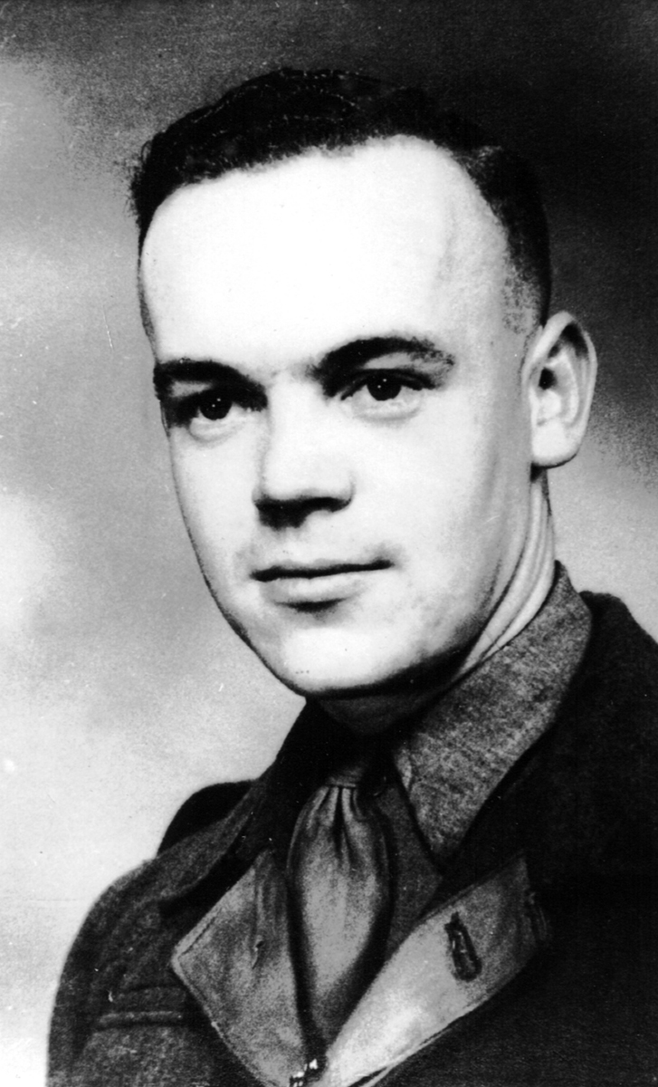

1926 - 1947

List of documents

All the documents we have discovered in our quest are numbered as shown below, and those numbers are used to identify them in the text:

- Birth Certificate – Albert Bayles
- Death Certificate – John Bayles
- Handwriting analysis results and samples submitted
- Record of Will search for John Bayles
- Death Certificate – Frederick Edward Charles George Mills
- Last Will and Testament – Frederick Edward Charles George Mills
- Pictures from Dallowgill

The start of things

Sylvia, Amanda and I began to research our family tree in 2005, with few ideas on how to begin or where we would end up.
One thing became clear as we began to speak to relatives and people who knew Mum’s family from Sowerby and St. Michael’s on Wyre was that Albert (Mum’s elder brother) was somehow different from his siblings and his peers.
He was being described as ‘very clever’, or as ‘Mam’s favourite’, also ‘better dressed than everyone else’, and he seemed to stand out on the few photographs we have of him.
A family story existed that Nanna had been offered the sum of £300 for Albert, but that she had refused. We speculated that such an offer may have been made by his father, who may have been Nanna’s employer, and who wanted a son and heir – maybe his wife couldn’t have any children – but £300 in 1926 was a lot of money.
A mystery! We determined to investigate and find out about Albert – maybe we had rich relatives, or maybe there would be an inheritance ……..
We knew that Albert was not our grandfather’s son, as Nanna had arrived at grandfather’s house as his housekeeper in 1928, with Albert in her arms. No-one in the family knew anything about his origins, and we wondered who his father was, and where he came from.

Was he adopted?
There was a belief that grandfather had adopted him, indeed he was using the name Albert Wedge on his sign-up papers for National Service in 1946, and he had been called Albert Wedge when he was at school in St. Michael’s on Wyre.
We also found that Albert would not necessarily have had to produce a birth certificate when he was called up for his National Service, just give his date and place of birth. It seems that he gave his place of birth as Sowerby Bridge in Yorkshire.
Checks with the General Register Office soon ruled that out, as there is no record of any such official adoption. It is possible that it was not recorded, or that it was done by the church. The legislation making it necessary to officially register adoptions came into force on the 1st January 1927, so it is possible that Albert was never formally adopted.
We knew that Nanna originated from Houghton-le-Spring, in County Durham, and the Census of 1901 contains the following information about her household:

15 George Street, Houghton-le-Spring

Henry Cresswell, head, 28 years, coal miner (hewer)

Mary Cresswell, wife, 27 years

Joseph Cresswell, son, 7 years

Emily Cresswell, daughter, 4 years

Veronika Cresswell, daughter, 2 years

Mary Cresswell, (Nanna) daughter, 7 months

We began our search for Albert, little realising how difficult this would prove to be.
According to Albert’s National Service record, he was born on 27th June 1926, at Sowerby Bridge in West Yorkshire. His mother, Mary Cresswell was unmarried, and we believed she was living in that area at the time, although we had no idea where or why.

The Mills Family
We also knew that Nanna was employed by a Mills family (Frederick Edward Charles George Mills and his wife Phyllis Helen – nee Mayhew) in Ripon, and that she cared for their little daughter, Eileen Mary Mills for some time – we think from 1921 to around 1923, as she had several dated photographs of Eileen Mary, two of which are shown below. Eileen Mary was born on 30th December 1919 at College Road, Ripon.

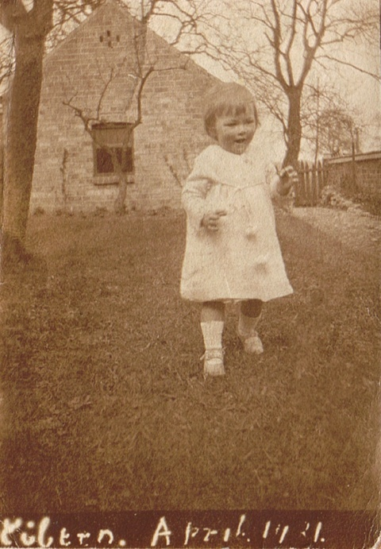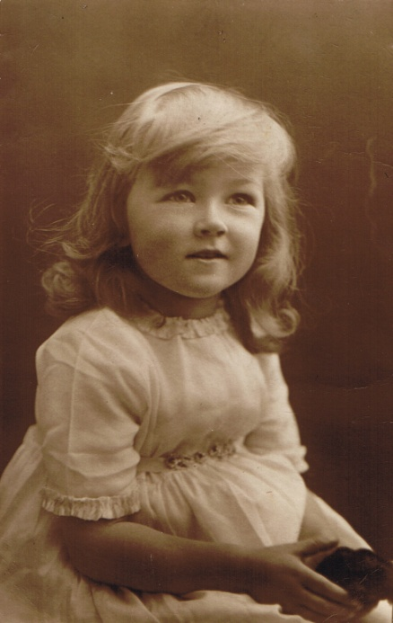
Eileen in April 1921 Eileen aged 3 (c 1922)
Enquiries about the Mills family found that they moved to 42 Griggs Road, Leyton, London in 1923. This can be confirmed by the Electoral Roll for the area, dated 15th April 1923. The property was new build, and was probably completed in late 1922, with the Mills family being the first occupants.
We had no idea where Nanna went between the Mills family moving to London, and the birth of Albert in 1926.
We wondered whether the tale of Nanna being offered £300 for Albert was true, and speculated that it might have been offered to her by Frederick Mills, either because he was Albert’s father, or because he and his wife could not have any more children and were desperate for a male heir.
So, we embarked on the next stage of our investigation, and found that Frederick died on 9th August 1949 in Ipswich. A copy of the death certificate (5) shows his wife, Phyllis, was present at the death.

Armed with this information we checked the Probate Office to see if Frederick had left a will, and if there was any mention of Albert in it. Sadly there was a will (6) but everything went to Phyllis and no other person was mentioned.
Of course, Frederick may have been aware of Albert’s death, which preceded his own by about 9 years, but it is probably more likely that he never knew what happened to Nanna and Albert.

The Colbecks and Orrs
Extensive searching of BMD records failed to reveal any boys by the name of Albert (with a mother whose maiden name was Cresswell) born in the Yorkshire area on the 27th June 1926. There was no record of an Albert Cresswell born anywhere on that date either.
We knew that Nanna became friendly with the Colbeck family, who lived in New Miller Dam, near Wakefield. Frances Colbeck (Auntie Auntie) married James Orr in late 1914, and they had four children, the oldest being John, who was aged about nine or ten in 1927, and who remembers helping to teach Albert to walk at New Miller Dam.
Sometime around 1927, the Orr family moved to St. Michael’s on Wyre in Lancashire.
Morris Colbeck (Frances’s brother) remained in New Miller Dam, and when his wife died in the summer of 1926, Nanna was employed doing housekeeping jobs for him. At this time she had already had Albert, and was living in a cottage opposite Morris. We have no idea who owned the cottage, if she rented it or whether the owner let her live there in return for some form of employment.
Nanna moved to St. Michaels on Wyre in 1927, and arrived with Albert on the doorstep of Frances and Jim Orr. There is no record of how long she stayed with them, but eventually she found that William Wedge, a retired police sergeant, of 1, New Cottages, Sowerby was in need of a housekeeper, as his wife, Sarah, had died in August 1926.
Mary was recommended to William, and sometime in early 1928 she arrived to take up the position of housekeeper, bringing Albert with her, and married William on 1st September 1928 at the Registry Office in Garstang.

The Bayles Connection

This is all the information we were able to find until September 2008, when a re-check of the BMD records (which are being updated all the time) revealed a birth record of an Albert Bayles, born in the second quarter of 1926 in the registration district of Ripon. The record also showed that the maiden name of his mother was Cresswell.

We sent for a copy of the birth certificate of Albert Bayles (1), and when it arrived it clearly showed that the birth date was 27th June 1926. It also showed the father as John Bayles, a shepherd, and the mother as Mary Bayles, formerly Cresswell, both of Cross Hills, Dallowgill. The birth was registered at Ripon on the 29th July 1926.

Further research into John Bayles revealed that he was born in Baldersdale in 1867 to Robert Bayles and his wife Hannah. John had 4 siblings, Robert born 1858, Isaac born 1859, Elizabeth born 1861 and Hannah born 1865.

In 1898, John married Sarah Jane Pratt in Teesdale. We can find no record of children for this marriage, and Sarah died in 1910.

In 1912 John remarried, to Alice Sutherland in Westmorland. We have found 2 children of this marriage, Mary Jane born 1912 and John George born 1915. Alice died in 1917.

John arrived in Dallowgill in 1919 to take up the job of shepherd, and his arrival is described by Lilian Chandler: ‘On the evening of 27th January 1919 John Bayles arrived at Cross Hills to be a shepherd on Dallowgill Moor. His furniture was transported by Clarkes motor from Ripon and it appears to be the first furniture removal by motor to be recorded in the Gill.
The motor was unable to leave the road and Tom Kirkley went with a horse and cart to lead the furniture across the moor. It was a pouring wet night and in the end the job had to be abandoned as everyone had got soaked. The remainder of the furniture was put in a shed at Castiles till the following day.’

Cross Hills was, at this time, owned by Thomas Grainger of Castiles Farm which was nearby.

John died on 23rd March 1927 at Cross Hills. The informant who registered the death was his daughter Mary Jane Bayles (2). We wondered if Nanna had already left the house by this time, as if she were the wife of John then it would have been normal for her to register the death, rather than a 15 year old daughter. The Register Office informed us that it would have been in order for a daughter of only 15 years to register her father’s death if she were deemed competent at the time.

Checks with HM Courts Service, York Probate Sub Registry, have revealed no record of an estate for John Bayles. This may be due to Probate not having been granted, as probate is generally not required if the estate is small. This seems likely in John’s case, as he was a shepherd and unlikely to have large assets. We have not been able to find out if he left anything to Nanna or to Albert from this search.

We have failed to find a record of a marriage for Mary Cresswell and John Bayles, we have checked the BMD records and also the parish records for Dallowgill to no avail.

We have found that parish records from St. Peter’s at Dallowgill show that Albert Bayles, son of John and Mary of Cross Hills, Dallowgill, was baptised on 8th August 1926 at St Peter’s church.
The records also show that John Bayles of Cross Hills, Dallowgill, was buried there on 26th March 1927.

Lilian Chandler describes the sale of the household effects of John Bayles following his death in 1927: ‘The total amount raised from the sale was £24 11s 8d and expenses amounted to £3 14s 6d which seems a large from such a small amount, leaving a sum of £20 17s 2d. A rocking chair sold for 9/-, a cupboard and drawers £3 and James Jackson of Low Raycarr bought an iron bedstead, mattress and feather bed for 14/-.’

So, it seems that Mary and Albert left Cross Hills around the time of John’s death, probably due to the house being ‘tied’ to John’s job as a shepherd.

Handwriting analysis

We have obtained copies of the original register entries for the birth of Albert Bayles and the death of John Bayles, which have the original signatures of the informants for the events.

These 2 signatures, and Nanna’s signature on the front page of her will were sent to a handwriting expert for comparison, and she finds that it is probable that the signature of Mary Bayles on the register of Albert’s birth was made by the same person (Nanna) who signed the first page of Nanna’s will (3).

So, it seems that we may have eventually solved the mystery of Albert’s father. He was John Bayles, a shepherd, of Cross Hills, Dallowgill in Yorkshire.

However, there still remains the question of the marriage (or lack of it) of John Bayles and Nanna. There is no record in the BMD records, or in the St Peter’s registers. John appears to have lived at Cross Hills for some time before Nanna arrived there, so it seems unlikely that they would have married elsewhere. If they didn’t marry it appears that the information given at the registration of Albert’s birth was not correct, and we can only speculate about the reasons for that.

We are still trying to find out more information about the Bayles family, and eventually hope to find a photograph of John Bayles to compare with photographs of Albert – maybe Albert will look like his father, who knows.

Albert went on to his National Service, and was killed in Palestine on 1st March 1947 while serving his country. His jeep was blown up by a roadside bomb, detonated by Jewish terrorists on the Mountain Road between Haifa and Mount Carmel. He was just 20 years old.

He was buried in the military cemetery at Khayat Beach near Haifa, and is also remembered on his mother’s headstone in St Thomas churchyard, in Garstang, Lancashire.

His older sister, our mother Mary, was presented with the Elizabeth Cross by the Lord Lieutenant of Lancashire on behalf of Her Majesty Queen Elizabeth II as a recognition of Albert’s death in service of this country.
Saint Peter’s Church, Dallowgill

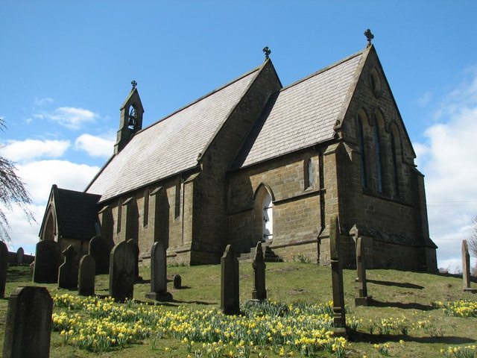

Cross Hills

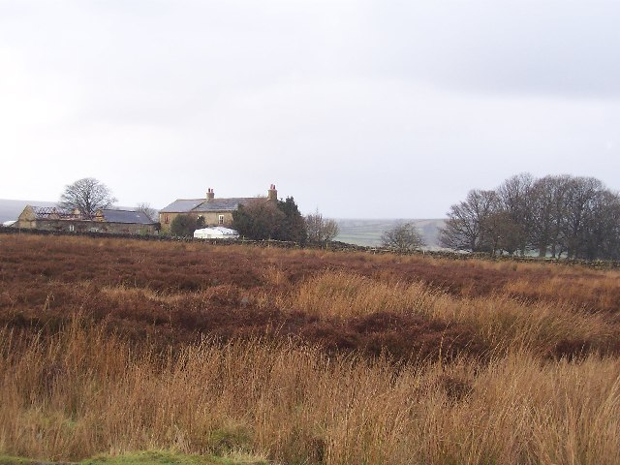

Dallowgill Through the Ages: Lilian Chandler 1991
Laverton and Dallowgill: Lilian Chandler 1994

