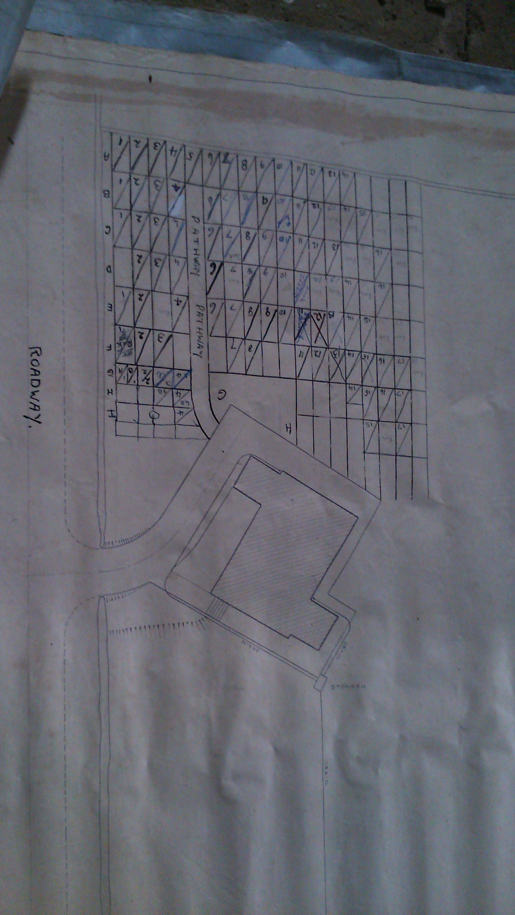

|  |
| --- |
| 1 Robert Burton |
| 2 Kate Burrill  3 Dora Chandler  4 John/Harriet King  5 No name  6 William Carter/Minnie Watson  7 George Thackwray  8 Florence Emily Thackwray  9 Leonard/Ellen Umpleby  10 John King  11 Ivan Wilcox  12 Geoffrey Douty Borrough Hopkins  12b David Sime Borrough Hopkins  12c Derek Malcom Nelson  13 William/Emily Chandler  14 Winifred Hannah/Lewis Burrill  15 Mary Burrill  16 Mary Lilian Hymas  17 Kathleen Connall  18 Leonard George Chandler  19 Susan Linda Chandler  20 Isobel Chandler  21 Mary Dorothy Downey  22 Kathleen Mary Molloy  23 Percy Foster Rainforth  24 Mary Elizabeth/Robinson Newbould  25 George Thornborrow/  Mary Elizabeth Nicholson  26 Annie/James Newbould  27 Clara/John Eric Spence  28 Jessie/John Richard Newbould  29 James/Grace Dora Chandler  30 Albert/Mary Newbould  31 Dorothy Nicholson  32 Ella Hutchinson  33 No name  34 Frank Milligan  35 No name  36 Norman John Ward  37 Mary Ward  38 Leonard/Nellie Burrill  39 Doris/Robert Lobley  40 Dorothy/John William Burrill  41 Garbutt Chapman |

42 Joseph Sidgwick

43 Annie Elizabeth/Francis William

Sidgwick

44 John Francis/Florence Sidgwick

45 Kathleen/Harry Sidgwick

46 Helen Forster/Garbutt Chapman/

Helen Sharpe

47 Raymond Chapman

48 Eva Burrill

49 Ada/Peter Burrill

50 William/Mary Jane Burrill

51 William Chandler

51b “Harry” J.H. Nicholson

52 Stanley/Eveline Pickles

53 No name

54 No name

55 Fred/Mary Jane Ashby

56 Florence Ethel Mann

57 Sidney/Annie Lobley

58 William Lobley

59 Lily/Joseph William Nelson

60 John William/Lilian Joyce Chandler

A1 Rebecca Cundall

A2 Lewis Burrill

61 Vera Key

62 Ronald Turner

63 Dora Nelson

64 Edward Nelson

65 Oliver/Enez Marjorie Ashby

66 Leonard/Mary Pearson

67 Rosina Ann Harford-Cross

68 Frederick Harford-Cross

69 Angus Iain Stuart Thompson

70 Richard Bradley Pearson

70b A. W. Kitching

70c Joan Kitching

71 Ronald Arthur Kitching

72 Ivy Dora Dawson

73 Eric Arthur Dawson

74 David K Scott

75 Heather Winlo

76 Ron Winlo

77 Irene Teresa Kerr

78 Douglas Frere Kerr

79 Alfred Simpson

80 Andrew Michael Harford-Cross

32

33

61

51

51b

Dallowgill Chapel of Resurrection –

Gravestones Plan

70c

2

1

Recorded 12th October 2014 updated 23rd December 2017

A1

A2

62

28

29

58

59

60

57

55

56

50

49

46

47

48

27

26

25

24

13

14

15

16

17

18

19

20

21

9

8

7

6

5

10

11

12

12b

12c

4

44

E4

70b

43

72

80

73

31

68

64

71

3

41

76

65

42

63

23

34

35

54

52

53

37

45

75

77

70

22

30

36

78

79

74

66

67

69

38

39

40